Visualisation COSC 6344

Assignment – 3

Task -1

1. To prepare the data instead of using a .ply file, a structure is used here.
2. This array contains the values of the points (x,y) and the temperature value(a).
3. The given generator function is used to compute the temperature values and the coordinates(x,y)

Task – 2

1. The above computed data points are visualized in two ways
2. Point Cloud:

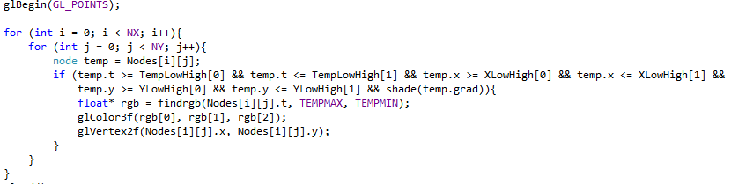

Here the values are not smooth because they are points and not surfaces.

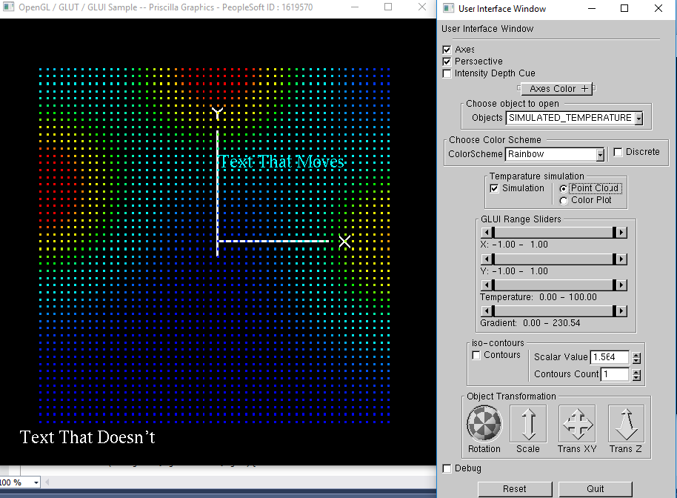

1. Color Plot:

The below code is repeated for all 2D surfaces(XY,YZ,XZ).

This generates a very smooth surface as shown in the output because surfaces are generated and not points.

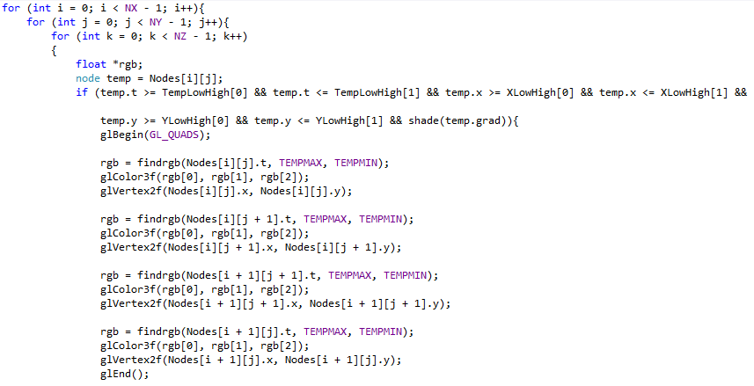

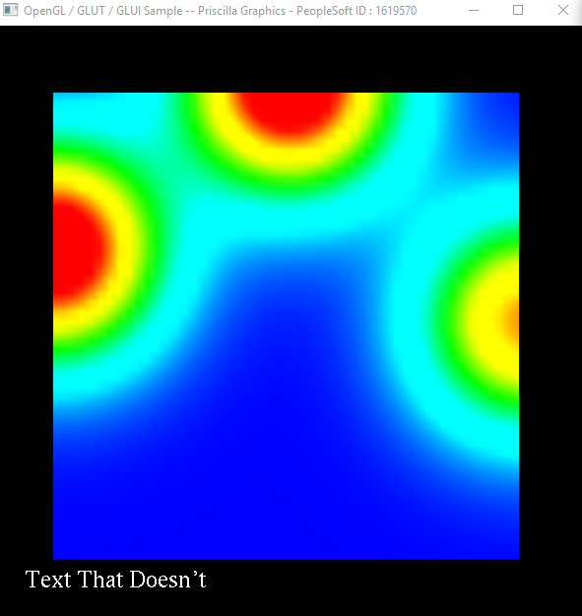

Task – 3

1. To implement GUI Sliders add new panel sliders on the GUI

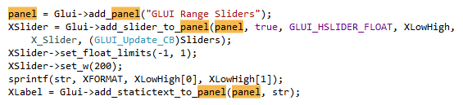

1. The above is to be repeated for all the other sliders. Set the upper limit, lower limit, format for the sliders in the call back function.

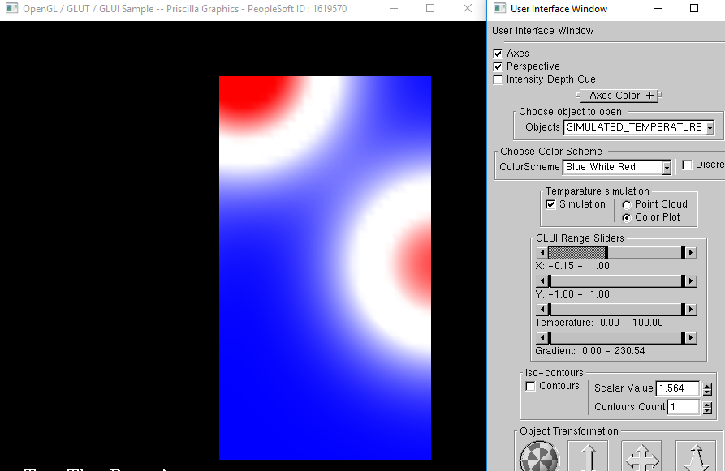

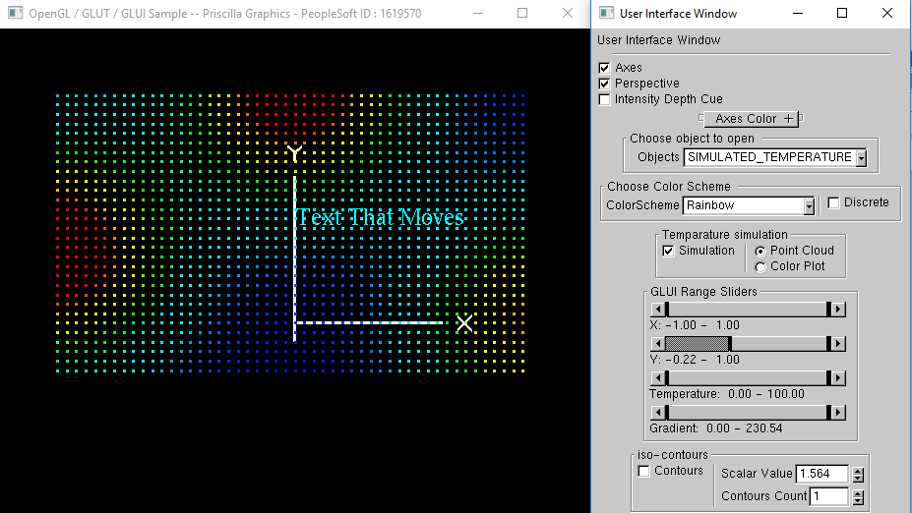

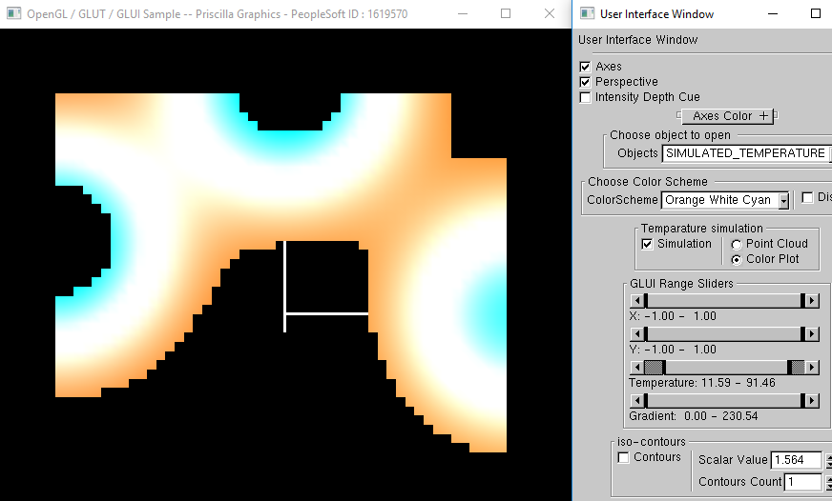

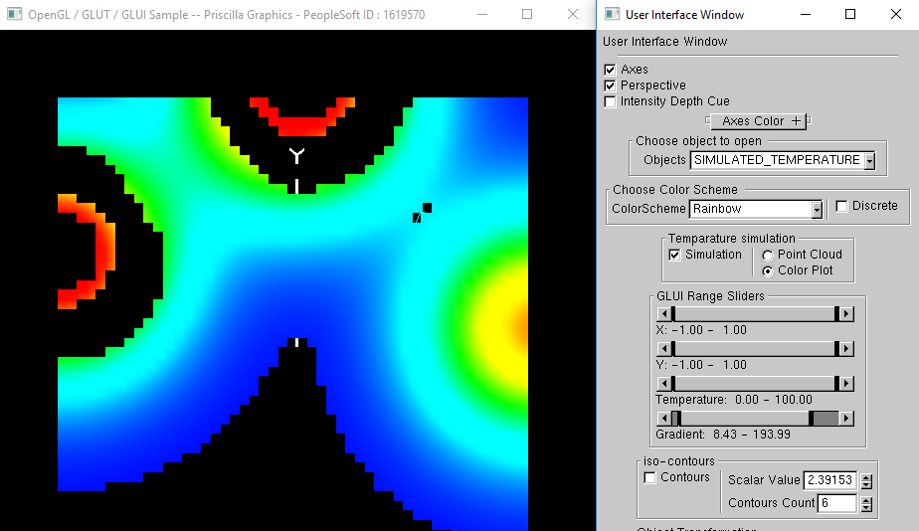

Task – 4

1. To generate the contours, first the points with the same temperature values are computed for every temperature value.
2. And then lines are constructed through all these contour points

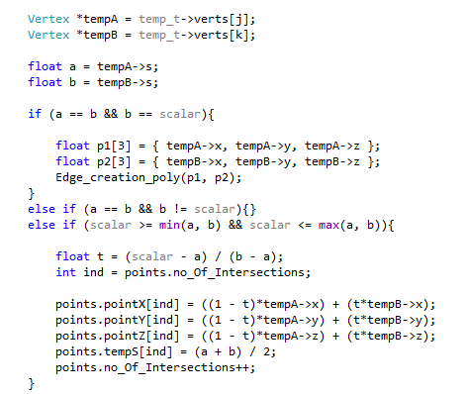

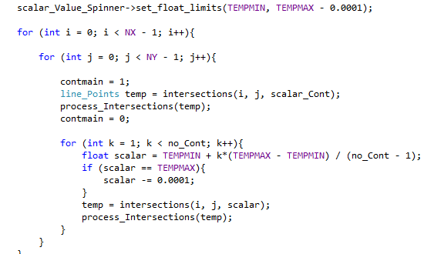

1. A contour counter is maintained which takes the input according to the number of contours given from the GUI.
2. The scalar value from the GUI is used to see a continuous contour wherever the user wants to see the contour.

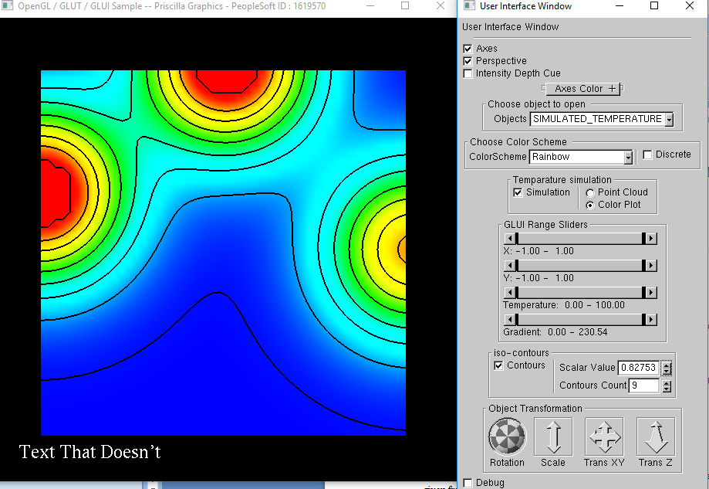

Task – 5

1. To get the triangular mesh isocontours, just like line intersections where the sides of quards are considered , here consider the three vertices of the triangles. This can be done either by dividing the quards to triangles.
2. And then following the same like wefolowed for the quards.

